**Executive Summary**

**Freight Data Analysis**

**Objective**

The objective of this analysis was to uncover patterns and trends in international trade data, focusing on freight charges, trade types, container usage, transport modes, and country-level trade activity. The goal is to provide actionable insights that help improve trade efficiency, cost management, and strategic prioritization.

**Key Business Questions & Insights**

**1. How does the use of containers influence freight charges?**

**Insight**: Non-containerized shipments incur significantly higher freight charges than containerized ones.

**Statistical Test**: ANOVA results showed a significant difference across groups (F=62.47, p<0.001).

Based on the ANOVA test (F-statistic: 62.4789, p-value: 0.0000), we found a statistically significant difference in average freight charges among the three container usage groups: Containerized, Non-Containerized and Unspecified.

**Recommendations**

**Encourage Use of Containerized Shipping**

- Containerized shipments are associated with lower average freight charges.

- Businesses should prioritize containerized logistics where possible to optimize shipping costs.

**Audit Non-Containerized Shipments**

- Investigate high-cost non-containerized shipments to:

- Identify opportunities for container conversion.

- Optimize packaging and logistics processes.

**Investigate 'Unspecified' Container Entries**

- A significant number of entries are labeled as "Unspecified", which may obscure analysis.

- Improve documentation and classification at data entry points.

- Ensure container status is accurately recorded for all shipments.

**Develop Cost Guidelines for Logistics Teams**

- Use container-type-specific freight cost averages to create internal cost benchmarks.

- Help logistics teams make cost-effective shipping decisions based on data.

**Collaborate with Freight Carriers**

- Present data showing the cost benefits of containerization in negotiations.

- Secure better pricing or incentives for choosing containerized transport.

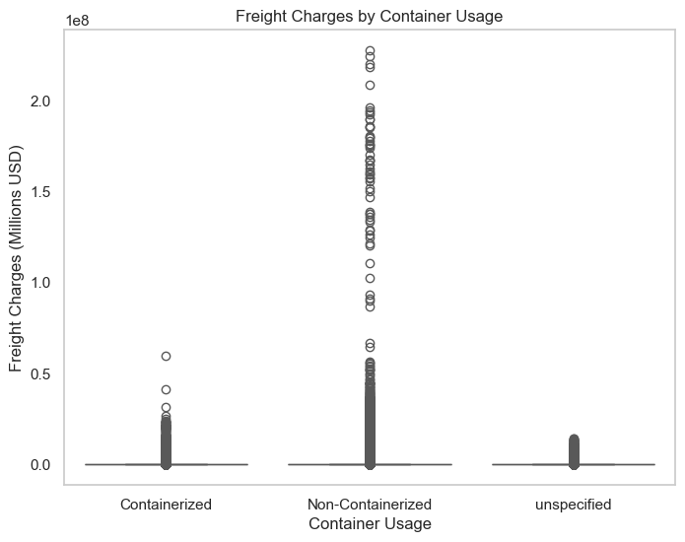

**2. How does the use of containers influence shipment weight?**

**Insight**:

- Non-Containerized shipments show significantly higher variability in shipment weights, including extreme outliers reaching up to 8000+ million units.

- Containerized shipments are more tightly clustered with relatively lower shipment weights.

- The Unspecified category tends to follow the same trend as Containerized shipments, indicating low weights and fewer extreme values.

**Recommendations:**

1. Review Large Non-Containerized Shipments:

- Investigate the operational, cost, and logistical factors driving extremely high shipment weights in non-containerized shipments.

- These may be contributing to inefficiencies or elevated freight costs.

2. Encourage Container Usage Where Feasible:

   - Promote the use of containers for large-volume shipments to help standardize handling and reduce risks associated with bulk shipments.

3. Segregate Unspecified Shipments:

   - Ensure clear classification of shipment types to avoid misinterpretation of trends and improve logistics planning.

The below insights support better decision-making on shipping strategy, cost control, and infrastructure planning in trade logistics.

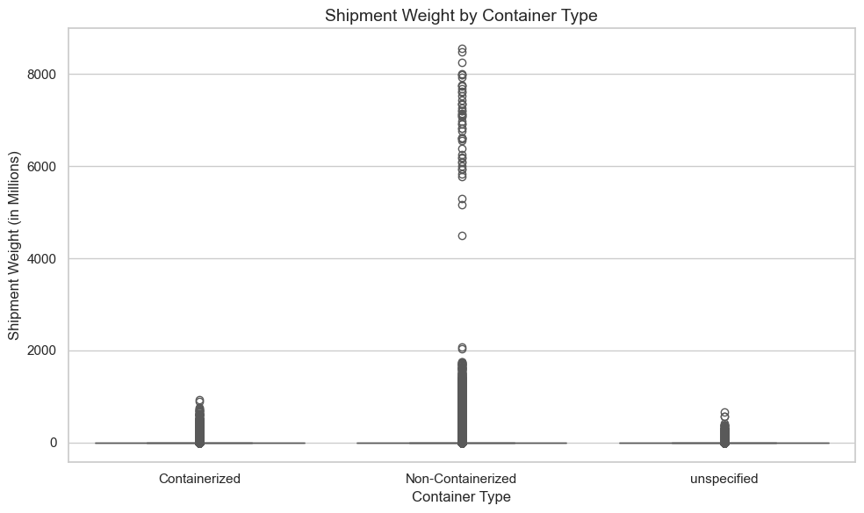

**3. Distribution of Goods Origin by Country?**

**Canada**:

   - Has the highest volume of unspecified origin shipments.

   - A significant volume of domestically produced goods is present.

   - Foreign-produced goods are the lowest among the three categories.

**Mexico**:

   - Dominated by domestically produced goods.

   - Foreign-produced and unspecified categories are relatively lower.

**Recommendations**

Improve Data Completeness

- The high proportion of unspecified origins in Canadian records could impact decision-making and trade analytics.

- Collaborate with customs and logistics data providers to enforce stricter data entry and reporting standards, especially for goods origin fields.

Tailored Trade Strategy

- For Canada: Focus on identifying sectors contributing most to unspecified entries and improve data clarity.

- For Mexico: Continue supporting local production and explore infrastructure improvements to sustain export strength.

Operational Efficiency

Review logistics processes (e.g., containerization, customs documentation) for countries with high data ambiguity to streamline supply chains.

Risk and Compliance

- High "unspecified" counts may indicate potential compliance or audit risks.

- Therefore Increase data validation protocols and implement additional checks for high-risk routes and trade partners.

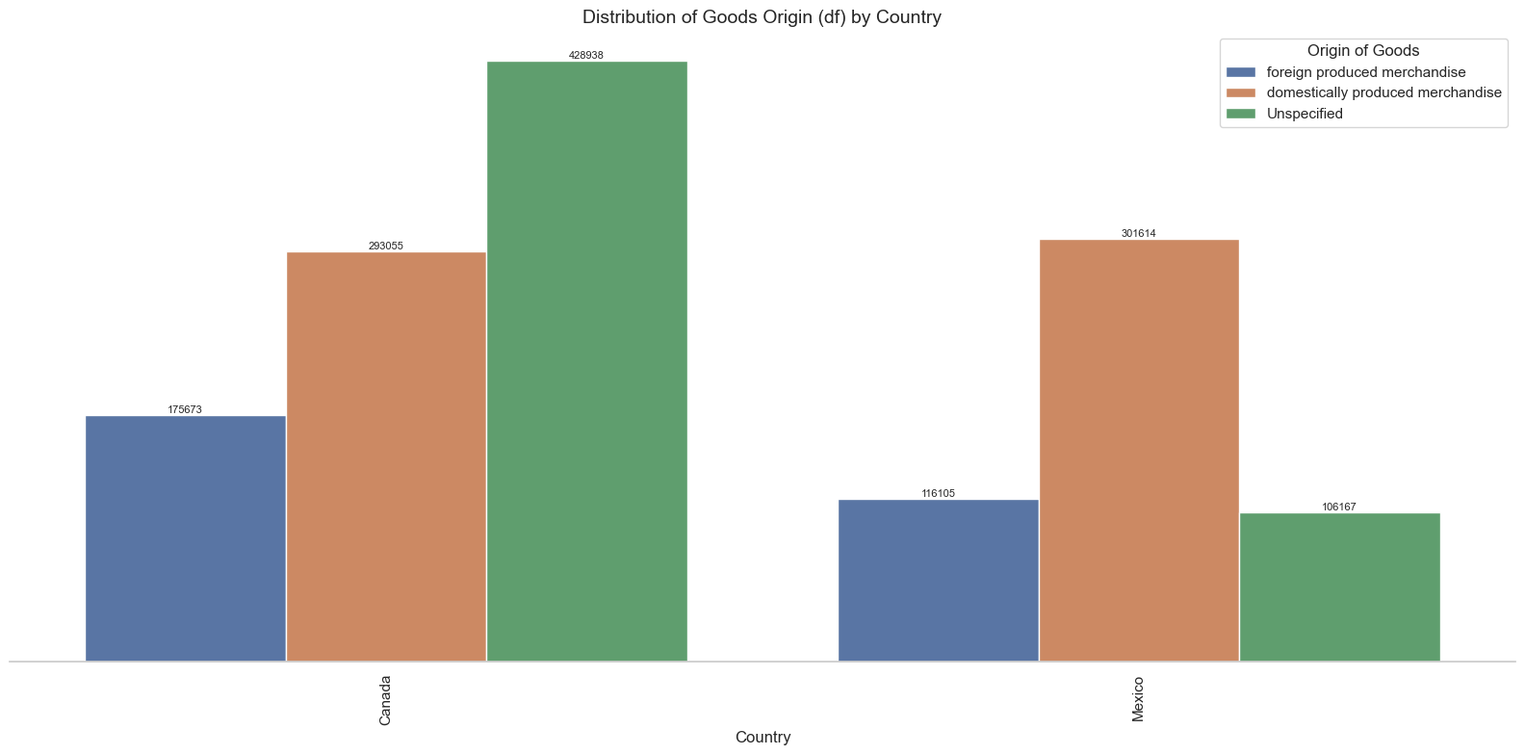

**4. What are the peak months for exports and imports?**

**Insight**: Trade activity peaks during specific months such as March, July, and October.

**Exports Consistently Surpass Imports**:

   - Every month, export volume is higher than import volume.

   - Peak export: March (89,391 units).

   - Lowest export: October (53,122 units).

**March and August are Strong Export Months**:

   - High volumes observed in March (89,391) and August (87,506).

   - These may indicate cyclical peaks or seasonal product trends.

**Lowest Volumes in Q4**:

   - October to December shows a noticeable decline in both exports and imports.

   - December is the lowest for imports (30,840 units) and exports remain moderate (51,793 units).

**Import Volumes are Relatively Stable Except in Q4**:

   - Ranges from 42,000 to 53,000 for most of the years.

   - Drop to 31,000–32,000 range in November and December.

**Recommendations**

**Capitalize on Peak Months (March & August)**:

   - Plan marketing campaigns, product launches, or high-volume contracts to align with these strong months.

   - Ensure warehouse and logistics readiness for increased outbound activity.

**Investigate Q4 Decline**:

   - Analyze causes: holiday closures, budget cycles, policy shifts, or reduced consumer demand.

   - Adjust forecasting and production accordingly.

**Boost Import Efficiency in Q4**:

   - Consider stockpiling inventory ahead of Q4 if lower imports are seasonal or supply-related.

   - Explore diversifying suppliers to maintain inventory levels in low-volume months.

**Align Freight Strategy with Volume Trends**:

   - Match freight contract terms and container bookings with monthly distribution patterns.

   - Consolidate shipments in lower volume months to reduce per-unit freight costs.

**Consider Dynamic Resourcing**:

   - Scale workforce, transport, and storage based on seasonal demand (Q1/Q3 upscaling, Q4 downscaling).

   - Use predictive models to optimize resource allocation.

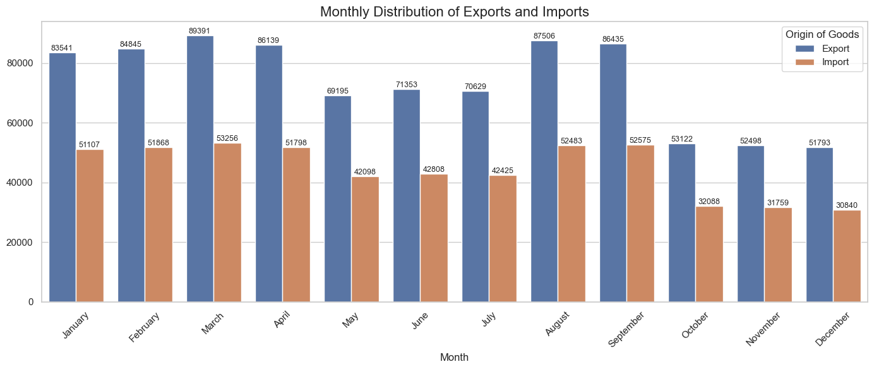

**5. Monthly Freight Charges Analysis by Trade Type**

Import Charges are Consistently Higher:

- Imports consistently incur higher freight charges than exports. Peak: March (5869.8M), Lowest: October (3489.0M).

Export Charges Show less Volatility:

- Peaks observed in March (2501.9M) and August (2378.3M).

- Gradual decline in Q4, ending with December (1375.6M).

Sharp Drop in Both Trade Types in October:

- Potential external influence (e.g., holidays, trade policies, port delays).

- A key month to investigate further.

High Freight Activity in Q1 and Q3:

- March and August are top months for both import and export volumes.

- Indicates seasonality or planned trade surges.

**Recommendations**

Investigate the October Drop:

- Analyze potential causes: seasonal effects, regulatory changes, or demand shocks.

- Adjust operational plans or mitigate potential risks during Q4.

Capitalize on Strong Months (March & August):

- Align promotions, contracts, and logistics strategies with these peaks.

- Ensure supply chain readiness and sufficient transport capacity.

Optimize Import Freight Costs:

- Imports form the bulk of freight expenses, consider:

- Freight consolidation.

- Rate renegotiation with carriers.

- Alternative sourcing strategies.

Enhance Export Activity:

- Incentivize outbound trade through:

- Export support programs.

- Strategic pricing.

- Exploring new markets.

Integrate Forecasting & Budgeting:

- Use monthly trends to forecast future costs.

- Inform budget allocation and strategic planning on a quarterly basis.

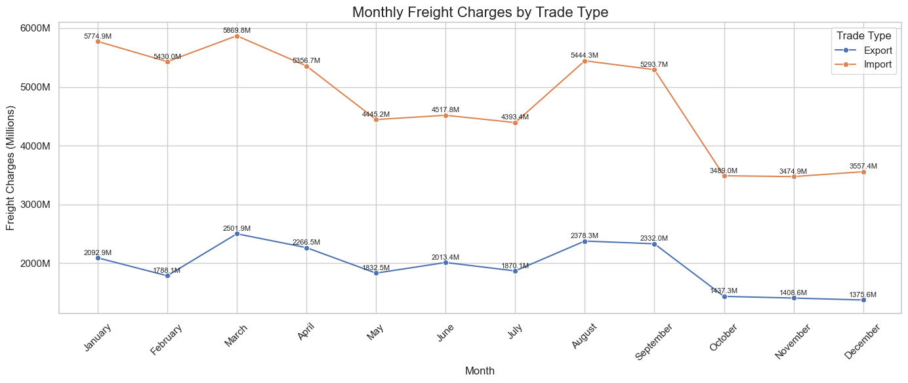

**6. Frequently Used Modes of Transport**

**Insight**: The chart reveals that Truck transport dominates as the most frequently used mode, with 789,038 recorded instances.

This is followed by Air (278,542) and Rail (209,491).

- Trucks handle the majority of shipments, indicating a strong reliance on road networks.

- Air and rail follow as secondary modes, likely used for speed and bulk capacity respectively.

- Maritime transport (Vessels), though globally significant, appears underutilized in this dataset with only 43,597 records.

- Pipelines, FTZs, and mail services have minimal activity.

**Recommendation:**

Invest in Road Infrastructure: Prioritize the maintenance and expansion of trucking corridors to support high volume traffic and reduce delays.

Balance Modal Usage: Encourage diversification by promoting rail and vessel use where feasible to optimize cost and environmental impact.

Analyze Bottlenecks: Conduct further analysis to determine why air and vessel usage is lower. Are there regulatory, capacity, or pricing issues?

Policy Intervention: Develop incentives or partnerships to improve infrastructure for underutilized modes (e.g., FTZs or pipelines) for long-term resilience.

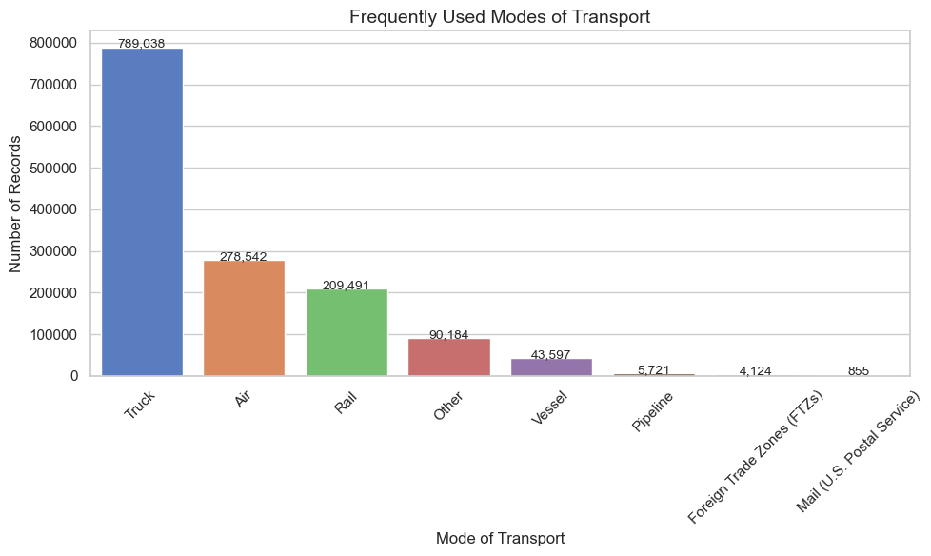

**7. Trade Type vs Freight Revenue**

From the chart, it is evident that Imports generate significantly higher freight revenue than Exports.

Imports account for approximately 57.05 billion in freight charges, while Exports contribute only about 23.30 billion.

**Recommendation:**

- Review Import Cost Structures: Since imports dominate freight revenue, it's important to evaluate cost-efficiency strategies with freight providers.

- Explore Export Opportunities: The relatively lower export freight revenue could indicate untapped potential in export activities.

Consider developing export incentives, better trade agreements, or expanding markets.

- Monitor Trade Imbalance Risks: A consistent revenue gap like this may reflect a trade imbalance. Understanding the underlying causes (demand, policy, and logistics) can help inform long-term strategic decisions.

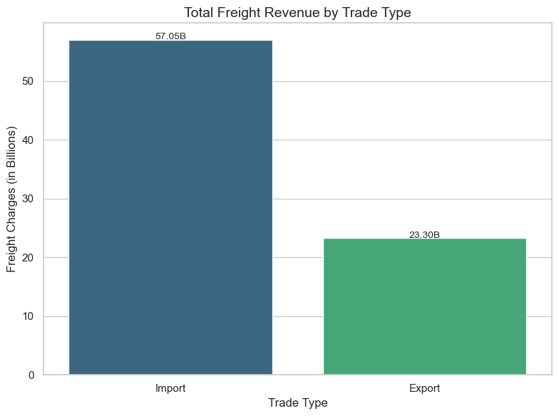**Additional Challenges Uncovered**

Despite significant advancements in trade infrastructure, the analysis reveals persistent issues such as:

* Safety concerns in transport operations.
* Infrastructure stress due to seasonal trade surges.
* Environmental impacts of non-containerized heavy shipments.
* Uneven economic trade relationships (deficits/surpluses).